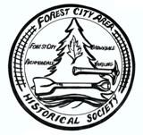
FOREST CITY AREA
HISTORICAL SOCIETY
NEWSLETTER
Volume: 1 Issue: 1 June, 2012
Mission Statement
Promote research, preservation and education relevant
to the history and historical artifacts in the towns of
Browndale (Wayne County), Forest City (Susquehanna County), Richmondale (Lackawanna County),
and Vandling (Lackawanna County) in Pennsylvania.

WELCOME to our first annual newsletter ! Well it has been two very exciting years and we have accomplished quite a bit. The following is a brief history of our first two years.
February 21, 2010 - organizational meeting held at Elegante's restaurant. Mr. John Kameen and Mr. Paul Ferraro led the group. They had prepared an agenda and a provided a brief history and purpose of the group. It was noted that a building (the former Shema Barber Shop on North Main Street) has been offered as a site to house the Historical Society. Discussion was held on the name of the organization. It was noted that the annual meeting will be in June and officers will be elected and take office at that meeting. Discussion was held on becoming Incorporated. Our neighbors from Greenfield Township Historical Society offered assistance in completing this paperwork process. Barb Klobucar volunteered to be the web site coordinator. And so we became a group, with a purpose and goal.
March 7, 2010 - A checking account was established, we filed for an EIN Number and 501(c)(3) non-profit status. Discussion was held on the property - the Shema Building. Discussion was held on what we want to accomplish. A web site report was given.
April 11, 2010 - Our guest speakers were Mark Walsh and Dale Kecklock.
May 2, 2010 - A nominating committee was established and information was provided on our first annual meeting. Bylaws were adopted, a membership application was approved, the 501(c)(3) application was ready for submission.
June 27, 2010 - Our first annual meeting with 38 members in attendance. The following were nominated for officers: John Kameen, President; Peggy Brager, Vice-President; Juliann Doyle, Secretary; and Joann Homisak for Treasurer. Our guest speak Mark Walsh spoke to us about the coal industry in the Forest City area from the 1880's through 1945. Our first fundraiser was a poster, which we had copies made, of the locations of the coal breakers in the area.
TO DATE WE HAVE:
- successfully transferred the Shema Building in our name;
- established a Lifetime Membership of $125.00;
- exhibits at our monthly meetings;
- exhibits during Old Home Week in 2010 and 2011;
- copied and sold the You Tube video of the Forest City area dated 1937;
- designed an emblem, mission statement and logo for the Historical Society;
- applied for and have received several grants to assist us in our projects;
- marched and rode on a float in the Old Home Week Light Parade and Saturday afternoon Parade;
- a web site, up and running and looking for more information;
- sponsored events for the community during Christmas time and for Memorial Day;
- Served as a collection site for artifacts of the FC Area
- Refurbished the Shema building with fresh paint and cleaned it out & made other necessary repairs;
- MOST importantly, we refurbished the mural of Forest City which was originally painted in 1985;
- Appointed a Curator, who has cataloged donated items;
- Established a Facebook account and keep it updated with our events, etc.

We have completed ALL of these projects and have more to come all because of you, our dedicated members.
Thank you, thank you, thank you for volunteering your time and your talents !! Each of you have helped to make us the wonderful organization we are today.
A special Thank You to our founding members:

Barbara Klobucar
Bernadette Slick
David Homisak
Dorothy Petrilak
Fran Gerchman
Frank Brager
Frank Gardner
Harry Newak
Ivy Carpenter
James Kuruts
Joann Homisak
John Kameen

Joseph Slick
Juliann Doyle
Marianne Stratford
Martha Matos
Mary Ferraro
Pat Williams
Paul Ferraro
Peggy Brager
Peggy Newak
Reyna Slick
Robert Wirts
William Allen

Clifford Township Historical Society presents TOP HATS AND LACE - 18th Century Victorian Dancers - on Sunday June 24 One o’clock at the Clifford Township Community Center 119 Cemetery Street in Clifford. Free Admission and refreshments Info 679-2723 This talented group of dancers have performed throughout NE PA. Their program of 18th century dances, including the Virginia Reel, coupled with period costumes makes for a wonderful show!! Don’t miss it!! Our museum of local history will also be open. Hope to see you there!!
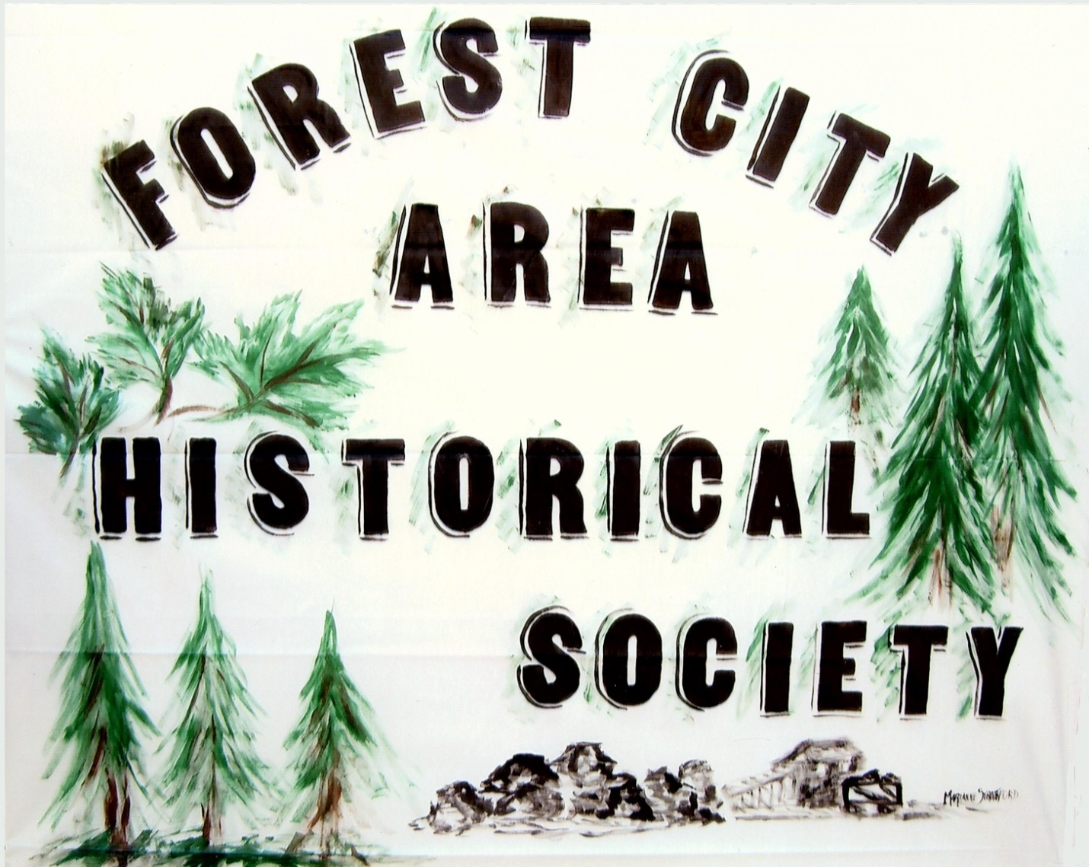

Members & Guests
Please join us at an upcoming Focus Group
LADIES
Sunday, July 8
immediately following our July meeting 7-8:15 PM

GENTLEMEN
Sunday, August 12 immediately following our August meeting 7-8:15 PM

Purpose: As most members know, the late John Obelenus wrote, in 1938, a work called “Highlights of Forest City Borough History.” His work was published (in the form of a small booklet of about 22,000 words) by the Forest City News. Mark Walsh, former Forest City resident has undertaken to update and expand the work, and as of this date has completed most (but not all) of the research and has written drafts of three (of a projected nine) chapters . We hope to complete the writing by early 2013, and to “go to press” in time to publish by Christmas of 2013 --- when the book, likely to contain nearly 100,000 words and at least 100 photos, will make one slam-dunk of a Christmas present! To continue our research, we propose to conduct a number of what are popularly known as “focused groups.” For our purpose we plan to use groups to determine what people think about the Forest City area. Keep this in mind: History isn’t just what happened in the distant past. History also includes what happened this morning! What present-day citizens think about the community is very much a part of the never-ending story. This is what we would like to do:

- We wish to organize two groups, one consisting of men, and one of women. Separation of the groups by sex is a
technique that, in our experience, encourages greater frankness in exchange of views. The groups are discussions, not “question and answer” sessions. The group moderator, Mark Walsh, offers up topic areas and encourages the discussion of them. Group members discuss the topics, not only with the moderator but also with each other. The moderator uses certain techniques to keep the discussions on track and/or in focus (thus the name), and to control the timing, so that the discussions do not go on all night!
- The discussions are recorded, but only to facilitate note-taking on the part of the group leader. After listening to the tape once or twice, it is erased. No record is kept of the names of group members; no quotation of any sort is attributed to any member; all members are assured of complete anonymity.
- No preparation is required of any member; all the participants have to do is show up and chat over coffee, which is on us.

Questions? E-mail Mark at SAMNMOLY@WARWICK.NET
(OR CALL 973 764-9035)

